
St. Patrick’s Day Math Art
- Shade the squares within the 10 x 10 grid to create your own St. Patrick’s Day picture!
- Complete the table to calculate the fraction and decimal for each color you used.
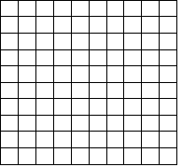
- Uncolored squares should be recorded in a row for the color white, and they should be part of your final calculations.

Color | Number of Shaded Squares | Number of Total Squares | Fraction | Decimal

